St. Francis Institute of Technology, Mumbai-400 103

**Department Of Information Technology**

A.Y. 2023-2024

Class: TE-ITA/B, Semester: V

Subject: **DevOps Lab**

**Experiment – 2: To understand version control system/ source code management, install git and create a GitHub account**

1. **Aim:** To understand version control using Git and create a GitHub account
2. **Objectives:** Aim of this experiment is that, the students will be able

* To be aware of different Version Control tools like GIT and GitHub
* To obtain complete knowledge of the “version control system” to effectively track changes augmented with Git and GitHub

1. **Outcomes:** After study of this experiment, the students will be able to

* GIT Installation
* Version Control
* Working with remote repository

1. **Prerequisite:** Knowledge of software engineering concept of version control
2. **Requirements:** Git,Personal Computer, Windows operating system, browser, Internet Connection, Microsoft Word.
3. **Pre-Experiment Exercise:**

**Brief Theory:** Refer shared material

1. **Laboratory Exercise**
   * + 1. **Procedure:**

**a. Answer the following:**

* Explain version control and its types
* What is Git and GitHub?
* Explain different Git commands

**b**. **Execute following on Git and GitHub (Refer the shared material) and attach screenshots:**

* Git installation
* Git commands
* GitHub account creation

1. **Post-Experiments Exercise**
2. **Extended Theory:**

Nil

1. **Questions:**

* What are the different Git areas? Explain with diagram
* What is a Git conflict?

1. **Conclusion:**

* Write what was performed in the experiment.
* Write the significance of the topic studied in the experiment.

1. **References:**

[**https://github.com/**](https://github.com/)

[**https://guides.github.com/activities/hello-world/**](https://guides.github.com/activities/hello-world/)

[**https://git-scm.com/docs/gittutorial**](https://git-scm.com/docs/gittutorial)

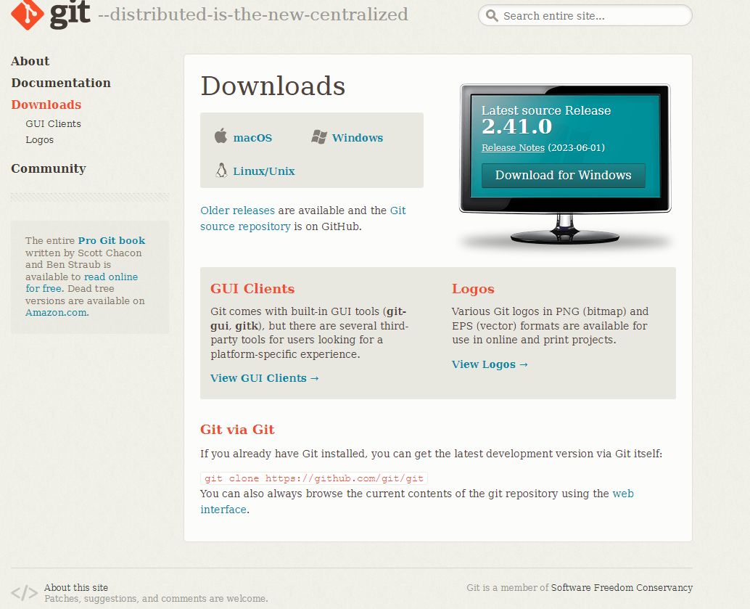

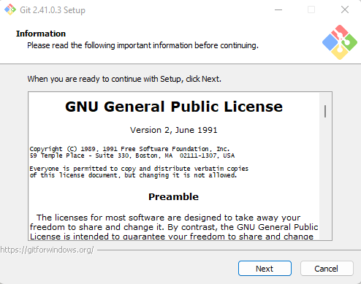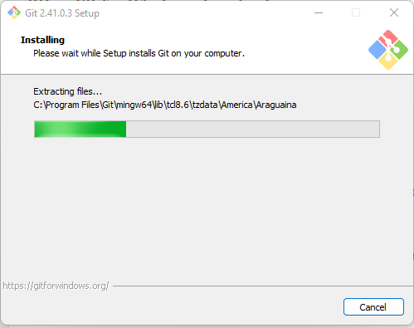

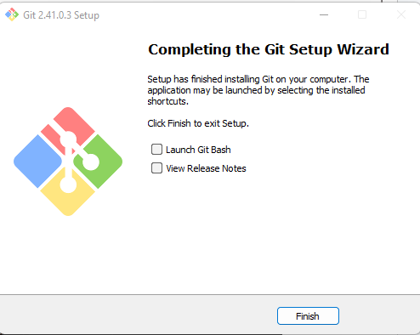

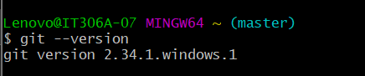

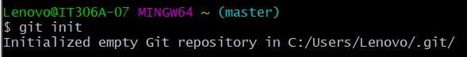g